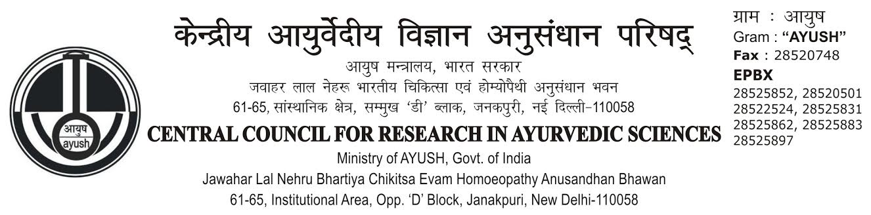
APPLICATION FOR NEW CGHS CARD FOR SERVING EMPLOYEES OF CENTRAL GOVERNMENT AUTONOMOUS BODY

1. | Name of the Applicant  (in capital letters) | : | __________________________________________________
2. | Category  (Please Tick Departmental if you are posted in the Ministry of AYUSH/Autonomous Body/CGHS) | : | Departmental | Services
3. | Name of the Department | : | Central Council for Research in Ayurvedic Sciences, Ministry of AYUSH, Govt. of India, New Delhi-110058
4. | Name of the Service  (In case of All India/Central Services-IAS/IPS. Etc.) | : | -NA-
5. | Designation | : | Gazetted | Non-Gazetted
6. | Pay Band: Rs.  (Current Pay Slip may be enclosed) | : | Present Pay Rs.___________ | Grade Pay Rs.____________
7. | Official Address | :
8. | Residential Address | :
9. | Telephone Number | : | (O)________________(R) _____________(M)
10. | E-mail ID | :
11. | Date of Superannuation | : | _____/________/_________
12. | Are you on Deputation  (Central Deputation) | : | Yes/No
13. | If yes, likely date completion of Deputation | : | ______________________________________
14. | Are your services transferable to other cities | : | Yes/No
Contd…..on..2/-

-: 2 :-
15. | Details of Family (*Please see definition of Family before filling up this column)
SI.No. | Name of Family Member  (in Capital letters) | Relationship with CGHS Card Holders | Date of Birth (#) | Blood Group  (Optional)
1.
2.
3.
4.
5.
6.
7.
(# Please attach Proof of age of Persons mentioned above)

16. | Are all the persons whose names are given above are dependent upon you and are residing with you? (Please attach proof of their staying with you, like copy of Ration Card/Election) |  |  | Yes/No
17. | Paste one ID Card Size of Photograph of each member of family (including self) whose names are proposed to be included as part of your family in the space given below:-
S.No………………….  Self  S.No…………………. |  | S.No………………….  S.No…………………. | S.No………………….  S.No…………………. |  | S.No………………….  S.No………………….
I undertake to intimate to CGHS/Department immediately if there is any Chance in dependency criteria of my family members included in this application form. If I fail to intimate and if the CGHS/Department comes to know of the change then the CGHS facility is liable to be withdrawn by the CGHS and the CGHS and/or appropriate authority will be free to initiate any action against me.
I undertake to surrender the CGHS Card(s) on my leaving the Ministry/Office on transfer/retirement/termination/resignation or on ceasing to be eligible for CGHS benefits.
I certify that the information furnished by me in this application has been verified to be correct and that no information has been concealed or has been misrepresented and stand by the same.
Enclosures:- Current Pay Slip (Govt. employee) card photo copy/Proof of Residence/Stay of dependents/Proof of age of each members. Disability certificate, if age of son is above 25 years.

Dated : _______________  Place : ________________ | Signature of Applicant _____________________________  Full Name :- _____________________________________  Designation : - ____________________________________

(TO BE FILLED BY THE SPONSORING AUTHORITY OF SERVING EMPLYEES OF AUTONOMOUS BODY)

The information furnished by the applicant has been verified and found to be correct. It is recommended that a CGHS Card be issued to Dr./Sh./Smt. ______________________________ Designation ___________________________ in this Ministry/Department/Council instruction are issued to the concerned Division to start deducting CGHS subscriptions every month from the salary of the applicant. I am authorized sponsoring authority for the issue of CGHS Card and approval of the competent authority has been obtained.

No. :
Date: ____________

Tel. 28525862, 28525831 & 28525897 (intercom No. 207)
Signature & Name of the Sponsoring Authority
(Stamp with Tel. Number)

To,
The Additional Director (HQ) (CGHS),
Office of the Additional Director (HQ),
Central Government Health Scheme, Govt. of India,
CGHS Building, Sector-13, R.K. Puram,
New Delhi-110022

Verified-by Authorized Signatory, CGHS (HQ),
CGHS Wellness Center (a.k.a. Dispensary) Allotted
__________________________________________ entitlement.
*(to be filled by CGHS)

Signature with Stamp

“Non Employment Certificate”

This is to certify that Sh./Smt./Ms. ___________________________________________ is wife/Husband/Daughter of Sh./Smt. _____________________________________________ is not employed in any Private/State/Central Govt. Organization.

Dated : _____________
Signature __________________________
Full Name__________________________
Designation __________________________
Address __________________________
__________________________
__________________________
__________________________

Counter Signature of the Officer In-Charge/
Institute/Centre/Unit/Unit (Along-with seal)

“Dependency Certificate”

I, _____________________________ declare that my mother/father namely Sh._____________________ Smt._________________________ Age _______ years is entirely dependent upon me and is permanently residing with me with effect from _______________. I, further declare that my mother/father is not an earning member and his/her total monthly income from all sources including income from land holding/rent on building etc. is Rs. ________/- Nil.

Dated : _____________
Signature __________________________
Full Name__________________________
Designation __________________________
Address __________________________
__________________________
__________________________
__________________________

Counter Signature of the Officer In-Charge/
Institute/Centre/Unit/Unit (Along-with seal)

F. No. Dated:
TO WHOMSOEVER IT MAY CONCERN

This is certify that Sh./Smt./Ms. ____________________________________________ husband/wife/Daughter of Smt./Sh. ________________________________________ is working in our Office/Department/Council as ________________________________________________ neither granted any medical allowances nor any Medical Facility from this Office/Department/Council.

Signature of the Officer
(Full name of the Officer)
With Seal
To,
Sh. __________________________
_____________________________
_____________________________

JOINT DECLARATION FORM

I, _____________________________________ hereby jointly declare that my husband/wife Sh./Smt. _______________________________ who employed in ___________________________________________________
_____________________________________________________ will not prefer Medical Claim from his/her Office.

Dated: ________________
Place: _________________

Signature of the employee.  Full Name _____________________  Designation ____________________  Office: ________________________  ______________________________ | Signature of the husband/wife.  ___________________________________  ___________________________________  ___________________________________  ___________________________________

